
ECE 544: Project 3
Microprocessor-based Closed-loop Motor Control
Spring 2022

Chase Bradley West
Josiah Sweeney

Table of Contents
Introduction 3
Hardware 3
Software 4
Threading Model 4
Parameter Input Thread 4
Display Thread 4
PID Thread 4
Interrupts 4
PID Controller Response 4
Conclusion 5

Introduction
This project was designed to give students practical experience with closed loop control. Closed-loop control involves using feedback from one or more sensors to adjust the input parameters that controller the output of the circuit. In this project, the control system regulates the speed of a motor with firmware executed in the context of a real-time operating system (RTOS). The shaft of the motor is connected to a metal hub which can have friction applied to it to change the load on the motor. The system then adjusts the PWM duty cycle to the motor to maintain the speed despite the load. The motor system can be seen below in figure 1.
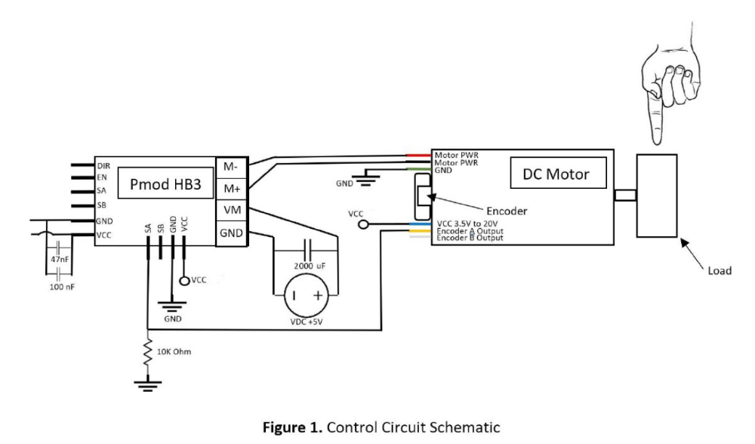

Hardware
For this project, we leveraged project IP utilized in Project 1 and Project 2, while making adjustments for the PMOD HB3 and using FreeRTOS for the first time. In addition to adding in the HB3, a watchdog timer was added, as well as adjusting the timer functionality so that FreeRTOS would work. One two channel GPIO was added with interrupt functionality, while a single GPIO output was utlized to operate the LEDs. As used in Project 1, the PmodOLEDrgb and PMODENC were both used, to show PID parameters and adjust the motor RPM, respectively.

Software

Threading Model
In our project, we tried to follow the model given with the project assignment with our threading model, creating a master thread instantiating the rest of FreeRTOS while having individual control threads for the display, parameters, and the PID controller.

Parameter Input Thread
The first thread that was developed was the parameter input thread. This takes buttons and switches read to a volatile variable in the interrupt and distributes them into their individual values. Based on what buttons or switches were changed in the interrupt, the task increments or decrements values to send on. Once the values have been calculated, they are sent on through message queues to be read by one or more following tasks. The are sent on unsigned long values that have been logically OR'd and shifted to accommodate for space.

Display Thread
The display thread simply takes the parameters sent out by the parameter thread in the queue, Kp, Ki, Kd, and the RPM setpoint, and displays them to the OLED screen and to the Seven Segment Display. The leds are also updated with the value selected on the PID selector on the Nexys switches.

PID Thread
Talk aboutr pid thread, maybe some pictures

Interrupts
In our Project 3 code, there are two interrupt handlers for the two types of interrupts that are triggered. There is a Watchdog timer, that will reset the program unless a keep alive signal is sent periodically through the threads, and a GPIO interrupt that will trigger when either the buttons or switches on the Nexys board are triggered.

PID Controller Response
Tbd graphs, plotter, and shit

Conclusion

